(Approx. 592 words)

Patching My PC with Patch My PC
by Alan German, Treasurer
Ottawa PC Users' Group, Ontario, Canada
https://opcug.ca
Editor: brigittelord (at) opcug.ca

With the demise of both Secunia's Personal Security Inspector (PSI) and Software Update Monitor (SUMo), I have been looking for an alternative vulnerability scanner or at least an update manager to help keep my applications up to date. My preferred option is open-source software or freeware; however, almost all the relevant scanners are commercial products. One program I tried recently is Patch My PC Home Updater, the freeware version of a commercial offering. While the free package is somewhat limited regarding the specific applications that are supported, many of the programs I frequently use are included in the list.

Patch My PC can be downloaded from the developer's website using the file PatchMyPC.exe. It's portable software, and no installation is required. So, it's sufficient to run the executable, which then scans the computer's system drive and reports on the status of the supported applications that it finds.

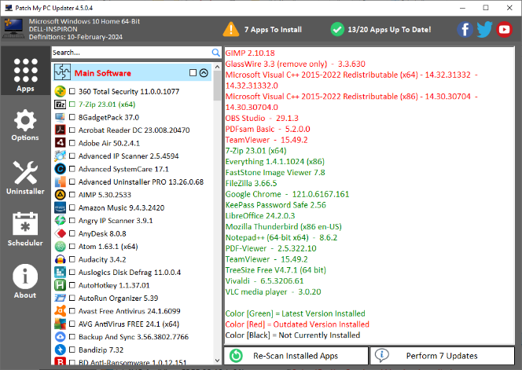

The user interface is pretty easy to understand. By default, the Apps icon in the left sidebar is enabled, and the list of applications is displayed. The left window lists all the supported applications. If an application is installed, the colour of the listing indicates its status. For example, 7-Zip Version 23.01 has been installed, and this is the current release of this utility. The right window displays any issues that have been identified. The applications listed in red are outdated and should be updated, while no action is required for those listed in green, which are currently available.

Note that PatchMyPC only looks at version numbers and determines if any package has a newer version available. So, it is not a vulnerability scanner. Some of the software updates may well include patches for vulnerabilities, while others may be just feature updates. Nevertheless, bringing all the listed applications up to date will ensure that at least these packages will receive any available vulnerability patches.

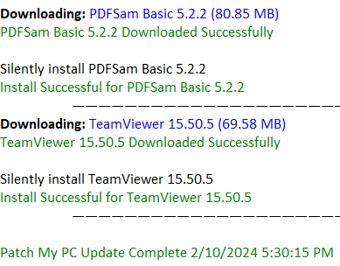
You can start updating the listed applications in red by simply pressing the button labeled Perform 7 Updates. PatchMyPC then downloads and "silently" installs the updated software. A progress report indicating successful downloads and installations is displayed in the right window.

A log file named PatchMyPC.log, stored in the folder where the PatchMyPC program is located, provides more details of the update process.

Interestingly, following the updates to my system, the header row in PatchMyPC indicated 19/20 Apps Up to Date. The log entry showed the reason as "Skipping install for GlassWire 3.3.664 based on user input not to close GlassWire.exe." I imagine this was a result of the "silent" update where I was not prompted to close GlassWire so that the update could proceed.

PatchMyPC has many customization features based on the categories listed as icons down the left sidebar. The Options tab includes customization for downloading software, changing the display, and managing the update process and the log file. The Uninstaller tab allows installed programs to be removed, while the Scheduler tab allows specification of the timing and frequency for running PatchMyPC automatically. It's also worth noting that, under the Apps tab, clicking the checkbox for any application in the list in the left window causes this application to be marked for installation the next time the software is updated.

So, PatchMyPC isn't an actual vulnerability scanner but a handy tool for keeping various installed applications up to date and making this process extremely easy.

Bottom Line
Patch My PC Home Updater
Patch My PC, LLC
https://patchmypc.com/home-updater

